Watershed and oceanic controls on spatial and temporal patterns of sediment deposition in a fringing reef embayment: Faga’alu Bay, American Samoa

by

Messina, A.M.1*, Biggs, T.W.1, Storlazzi, C.D.2

1 San Diego State University, Department of Geography, San Diego, CA 92182, amessina@rohan.sdsu.edu, +1-619-594-5437, tbiggs@mail.sdsu.edu, +1-619-594-0902

2 US Geological Survey, Pacific Coastal and Marine Science Center, Santa Cruz, CA 95060, cstorlazzi@usgs.gov, +1-831-460-7521, ocheriton@usgs.gov, +1-831-460-7579

Abstract

Keywords:

coral reefs,

Introduction

Problem

Increased suspended sediment concentrations over corals can reduce the health of coral reefs by attenuating photosynthetically active radiation (Storlazzi et al. 2015) and interfering with coral spawning (Erftemeijer et al. 2012). Increased benthic sediment accumulation rates can reduce the health of coral reefs by blocking all light for photosynthesis, causing tissue damage (Weber et al. 2012), blocking sites for larval recruitment, requiring energy expenditure from the coral to self-clean. Increased benthic sediment accumulation also decreases herbivory of algal turf (Bellwood and Fulton 2008) across coral reef depth gradient (Goatley and Bellwood 2012), and increased algal height can increase sediment trapping. Sediment can also decrease the growth of epilithic algae by developing black basal sediment layers high in hydrogen sulfide (Clausing et al. 2014), similar to the necrotic effects on corals (Weber et al. 2012). Under moderate sedimentation or high energy hydrodynamic conditions, herbivory can maintain short, healthy algal communities, but in slow-moving waters with high organic, terrigenous sediment the anoxic black basal layers are more common at shallower sediment depths (Clausing et al. 2014). Reduced herbivory of turf algae stabilizes a phase shift to an algae-dominated system as well as reduced fish biomass as the fish prefer to graze on algae free of sediment.

In general, finer terrigenous sediment with more organic material is more detrimental to coral health by more effectively attenuating PAR, increasing microbial activity resulting in necrosis of the underlying coral tissue, and requiring more energy from the coral for removal than coarser, coralline sediment (Erftemeijer et al. 2012; Weber et al. 2012; Storlazzi et al. 2015). Finer sediment is most easily resuspended and potentially advected from the reef to reduce the impact, or conversely, it may persist in suspension and increase the exposure time of corals. The impact of both suspended and accumulated sediment is determined by the duration and intensity of the exposure, which are controlled by the input and residence time of sediment (exposure=duration x intensity) and the hydrodynamic conditions over the reef. “It is evident that the understanding of fine-grained terrestrial sediment plume transport, deposition, reworking, and advection out of coral reefs is key to helping establish monitoring programs to determine the effectiveness of land-based watershed restoration conducted to support coral reef ecosystem health.” (Storlazzi et al. 2015)

Interaction of loading and hydrodynamics

The complex spatial and temporal interaction of terrigenous sediment inputs and hydrodynamic processes can significantly alter the quantity, composition, and residence time of sediment in coral reefs (Storlazzi et al. 2009). In contrast to many watersheds in temperate coastal regions where fluvial discharge and wave energy commonly coincide during “oceanic storms” (Warrick et al. 2004; Bever et al. 2011), discharge, deposition, and reworking of flood sediment are often decoupled on tropical islands, causing high deposition rates and residence times of terrigenous sediment (Draut et al. 2009; Storlazzi et al. 2009). Conversely, seasonal wind and wave patterns in the Trade wind belt can be coupled with sediment discharge or resuspension to decrease sediment deposition and residence times (Hoitink and Hoekstra 2003; Muzuka et al. 2010). Given the increased SSY to coastal waters caused by anthropogenic watershed disturbance on many tropical islands in the South Pacific and elsewhere (Messina and Biggs; Hettler et al. 1997; Ramos-Scharrón and Macdonald 2007; Bégin et al. 2014), an integrated understanding of how flood-supplied terrigenous sediment and water circulation control sediment deposition and residence time is essential for identifying and mitigating coral health impacts (Draut et al. 2009).

Sediment sources: can be watershed during events or resuspended from past events

Spatial:

Due to logistical constraints, many conservation planning and remediation studies often use coarse estimates of pollutant discharge and distance-based plume models that assume symmetry in flow fields (Klein et al. 2012). Some studies correlate long term sediment accumulation, and by extension decreased coral health, with increased suspended sediment yield (SSY) from the watershed (Ryan et al. 2008), but there is also evidence of hydrodynamics decreasing sediment residence time in two ways: 1) by flushing suspended sediment away from the corals before it can be deposited (residence time = 0 min), and 2) resuspending and removing sediment that has been previously deposited (Hoitink and Hoekstra 2003).

Temporal

Correlation with watershed loading/Modeling approach

While some studies correlate increase sediment accumulation with increased SSY from the watershed, several studies have found weak or no correlation between sediment trap collection and rainfall (Bothner et al. 2006; Victor et al. 2006). It is well-known that SSY from small, mountainous watersheds can be poorly correlated with precipitation (Basher et al. 2011; Duvert et al. 2012), and where management activities reduce SSY from storm events, it is necessary to measure SSY from the watershed. This paper uses measured and modeled SSY from the watershed, modeled wave conditions, and spatially distributed measurements of gross and net sediment accumulation to determine the spatial and temporal patterns of sediment stress at the study site. The proposed modeling approach is similar to other efforts that have attempted to limit the complexity of the modeling approach, but still account for the impact of ocean conditions and watershed processes on sediment dynamics (Fabricius et al. 2012).

Measurement Methods

Coral health surveys can’t distinguish between multiple stressors and

Many researchers and environmental managers are interested in determining the location and severity of terrigenous sediment impacts on coral health, but developing a measure of sediment impact has proven difficult. Coral surveys can monitor changes in coral abundance or species composition to infer impacts from sediment but it can be difficult to determine if those changes are caused by other factors, and coral responses can be non-linear (Hopley 2011). Management actions may reduce sediment stress to coral reefs but coral health may not recover due to other stressors, or the decadal time scale of coral recovery can be too long to be useful for managers. Bio-indicators like gene-expression or incorporation into coral skeleton (Fallon et al. 2002; Downs et al. 2012; Rotmann and Thomas 2012) are useful to determine if particular corals are being impacted, especially at sub-lethal levels, but determining the processes is difficult. Some have measured measuring SSC in the water column with turbidimeters or grab samples (Wolanski et al. 2003; Fabricius et al. 2012) to determine if areas are exposed to sediment stress but they don’t show if sediment is accumulating on the coral, the residence time, or the composition, which are important for overall impact (Weber et al. 2012). Thus, direct measurements of sediment accumulation and composition are preferred.

Thomas and Ridd (2004) review various discontinuous and quasi-continuous methods for measuring sediment accumulation at short timescales. Tube traps are the most common method for measuring sediment accumulation in shallow coral reef environments (White 1990; Storlazzi et al. 2011), but it is difficult to determine if these are ecologically meaningful indicators of coral stress. Some corals are well-adapted to turbid conditions (Perry et al. 2012), and deposited sediment can be removed actively by the coral itself, or passively by wave action before it is lethal. The stress on the coral organism increases linearly with the deposition amount and the duration of exposure (Fabricius 2005) but tube traps overestimate deposition and do not allow for sediment resuspension, making it impossible to evaluate the residence time of deposited sediment (Storlazzi et al. 2011). To more accurately quantify “net” sediment accumulation, Field et al. (2012) proposed the use of “SedPods” where a flat surface allows for resuspension, similar to the surrounding benthic substrate. Deploying both Tubes and SedPods in combination would provide information on “gross” deposition (in Tubes) and be comparable with previous studies that only used tubes, but few examples exist in the literature (Field et al. 2012). Deploying a TUBE in conjunction with a SedPod will allow comparison of gross and net sediment accumulation, and an assessment of the interaction of sediment loading and removal at time scales relevant to coral mortality and management.

Research Questions

Faga’alu is exposed to enhanced sediment input, hydrodynamics are heterogeneous, so where and when is sediment accumulation occurring?

The research questions for this paper are:

1. What are the spatial patterns of terrigenous and coralline sediment accumulation?

Hypothesis:

a) Total sediment accumulation will be lower on the south reef, due to oceanic flushing, and higher on the north reef where the sediment plume is deflected by wave forcing.

b) Terrigenous sediment accumulation will be highest near the stream outlet and on the north reef

1. What are the temporal patterns of terrigenous and coralline sediment accumulation?

At each site? Over the northern and southern reefs?

Hypothesis:

a) Terrigenous sediment accumulation will be high when SSY from the watershed is high, and low when waves are high

b) Coralline sediment accumulation will be high when waves are high due to resuspension

1. How do flood-supplied terrigenous sediment and hydrodynamic conditions interact to control the gross and net rate of terrigenous sediment deposition at monthly time scales in a coral reef embayment?

Hypothesis:

a) High waves will reduce terrigenous sediment accumulation by flushing.

Materials and Methods

*Study area*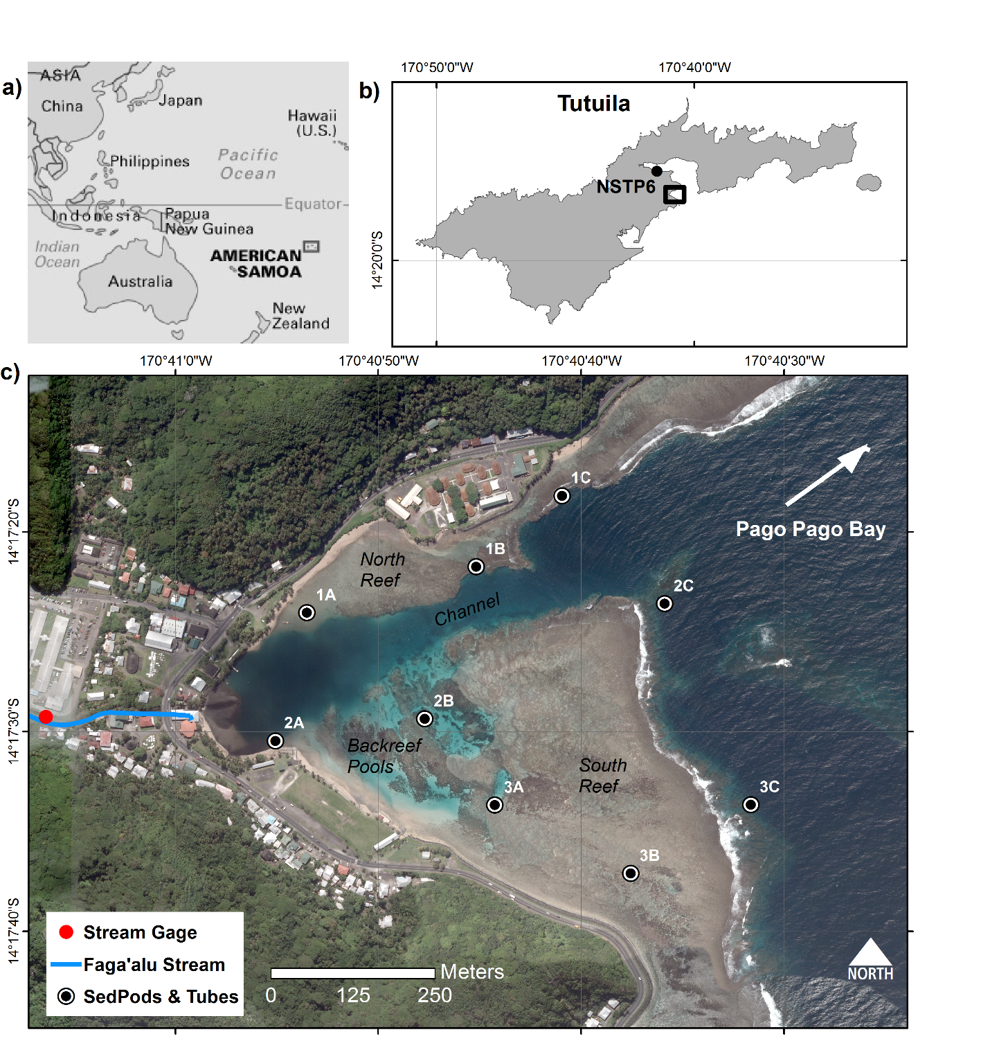

Figure 1. Study area

Faga'alu Bay is a v-shaped embayment situated on the western side of Pago Pago Bay, on the island of Tutuila, American Samoa (14.290˚ S, 170.677˚ W; Figure 1). The bathymetrically complex reef is characterized by a shallow reef flat extending from shore to the reef crest, where it descends at an approximately 1:1 slope to an insular shelf at approximately 20 m depth. See Cochran et al. (2016) for a detailed description of the bathymetry. Near the reef crest, the reef flat is primarily cemented reef pavement, but within a few 10s of m, transitions into thickets of primarily *Acropora spp.* Surveys in 2015 found coral coverage varied from less than 10% over the degraded northern area, to more than 50% on the more intact southern area (Cochran et al. 2016). An anthropogenically-altered, vertical-walled, 5-15 m deep paleostream channel (Figure 1) extends from the outlet of Faga'alu Stream eastward to Pago Pago Bay; this channel divides the reef into a larger, more exposed southern section (“southern reef” in Figure 1), and a smaller, more sheltered northern section (“northern reef” in Figure 1). Closer to the shore in the southern back-reef there are areas of deeper (1-5 m) sediment-floored pools with coral bommies (“back-reef pools” in Figure 1).

The bay is surrounded by high topography that blocks wet-season northerly winds from October to April, but is exposed to dry-season southeasterly trade winds and accompanying short-period wind waves from May to September (Craig 2009). Tropical cyclones typically occur in the South Pacific from November to April (Militello et al. 2003), impacting American Samoa every 1-13 years since 1981 (Craig 2009), though high waves impacting the reefs without the storm making landfall occurs more frequently (Feagaimaalii-Luamanu 2016). A semi-diurnal, microtidal regime exposes parts of the shallow reef crest and reef flat at extreme low tides. Faga'alu Bay is only open to south to southeast swell directions, and the more southerly angled swell must refract to the west, resulting in a reduction of wave energy. Offshore significant wave heights (*Hs*) are generally less than 2.5 m and rarely exceed 3.0 m. Peak wave periods (*Tp*) are generally about 9 s or less, rarely exceed 13 s, but occasionally reach 25 s during austral winter storms (Thompson and Demirbilek 2002). O. Vetter (unpublished data) recorded *Hs* up to 1.7 m on the fore reef in Faga'alu, but *Hs* greater than 1.0 m were rare.

Drifter and current meter deployments in 2014 showed mean flow speeds (residence times) varied widely over the reef flat, from 1-20 cm s-1 (2.8-0.14 h), 1-19 cm s-1 (2.8-0.15 h), and 1-36 cm s-1 (2.8-0.08 h) under strong wind, tidal, and large wave forcing, respectively (Messina et al., In Press). The highest flow speeds and shortest residence times occurred over the exposed southern reef and near the reef crest. The slowest flow speeds and longest residence times occurred over the sheltered northern reef, near shore, and the deep channel incised in the reef. Under tidal forcing (i.e., calm conditions), flow directions were the most variable, with some seaward transport from the reef flat to the fore reef. Under onshore wind forcing, flow directions were mostly into the embayment. Under large wave forcing, flows followed a clockwise spatial pattern: onshore over the exposed southern reef, onto the sheltered northern reef, and out to sea through the channel.

Faga’alu Bay is adjacent to a small (2.48 km2), steep-sided watershed that discharges terrigenous sediment during storm events from a perennial stream in the northwest corner of the Bay, and several surrounding ephemeral streams (Messina and Biggs, In Press). Sediment rich plumes are deflected over the northern part of the Bay and out to sea by the prevailing currents over the reef flat (Messina et al.) (Figure 2).

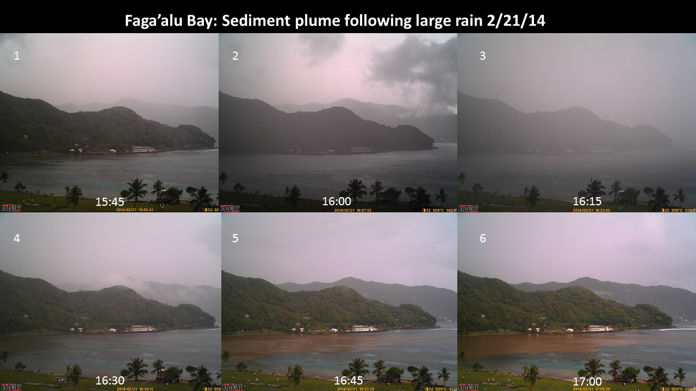

Figure 2. Time series of sediment plume following a brief but intense rainfall

Measuring sediment accumulation on the reef

A flat-surfaced “SedPod” (Field et al. 2012) and a Simple Tube Trap (Tube) were attached to a cement block at each of nine locations in Faga’alu Bay, six on the reef flat (water depth 1-2 m) and three on the forereef (10-15 m) (Figure 1, Table 1). Traps were located to sample the hypothesized spatial gradient of sediment accumulation from the stream outlet to the sea, and from the south to north reefs. A monthly time interval was chosen to correspond with other studies found in the literature (Victor et al. 2006; Muzuka et al. 2010), to include enough storm events to collect enough sediment for analysis, and for logistical reasons due to the high spatial coverage of sites and limited field personnel and resources. Collection dates varied due to safety concerns over dangerous diving conditions on the forereef. Deployments varied from 24 to 53 days, with a mean deployment of 36 days.

SedPods were made from 15.25 cm diameter PVC pipe, approximately 12 cm tall, and filled with cement with three eye-bolts to act as rebar and attachment points. The cement was poured on a rough piece of plywood to give it a slight texture approximating natural rock (Field et al. 2012). To collect the sediment from SedPods, a rubber pipe end cap was carefully slipped over the SedPod, and the stainless steel hose clamp was tightened to prevent sediment from escaping (Figure 3). In the lab, the rubber cap was removed and the sediment on the surface of the SedPod was rinsed off and analyzed for grain size and contribution. In many instances there was significant algal growth on the SedPod surface, so sediment was manually scrubbed from this algae layer and included in the analysis.

Tubes were made from 5 cm internal diameter PVC pipe, approximately 30 cm tall, and capped at the bottom. To collect the sediment from the Tube, a PVC cap was slipped over the open end, and then the Tube was removed from the block. In the lab, the cap was removed and the sediment was rinsed from the inside of the Tube. Some studies deploy multiple Tubes at each site to determine an average collection rate, and Bothner et al. (2006) found co-located Tubes differed by 11% on average. This study deployed a single Tube due to logistical constraints.

Sediment was wet sieved to separate the coarse and fine fractions (gravel size sediment was removed from the analysis), and the fine fraction was collected on pre-weighed 15 cm diameter 2 μm glass fiber filters. To remove salts, the coarse fraction was rinsed in the sieve with distilled water, while the fine fraction was gravity rinsed with distilled water several times. Coarse and fine fractions were dried at 100 C for 2 hours, cooled, and weighed to determine the bulk sediment weight. The sediment samples were then analyzed for geochemical composition (percent organic, terrigenous, and carbonate) using Loss on Ignition (LOI) method (Heiri et al. 2001; Santisteban et al. 2004). The average daily collection rate was calculated by measuring the total mass of sediment in the Tube or on the SedPod, and dividing by the trap cross-sectional area and the duration of collection period (Storlazzi et al. 2009).

Suspended Sediment Yield from the Watershed

Using continuous measurements of water discharge (Q) and Suspended Sediment Concentration (SSC) near the outlet of Faga’alu Stream (“Stream Gage”, Figure 1), Messina and Biggs (In Press) developed an empirical model of event-wise suspended sediment yield (SSYEV) predicted from maximum event water discharge (Qmax). Sediment mitigation efforts in the watershed were completed in October, 2014 (Holst-Rice et al. 2016), and significantly reduced SSY to the Bay (Messina and Biggs, In Preparation). A second Qmax-SSYEV model was calibrated for the time period following the sediment mitigation, October 2014-April 2015, to reflect the reduction in SSYEV from the same magnitude Qmax.

A time-series of SSYEV to the Bay during the study period was developed from measured SSYEV when both Q and SSC data were available, and SSYEV predicted from the empirical Qmax-SSYEV models when only Q data were available. SSY (tons) to the Bay during sediment trap deployment periods was calculated by summing SSYEV from Faga’alu Stream over the deployment period:

|  |  |  |
| --- | --- | --- |
|  |  | Equation 1 |
|  | | |

where SW is the sum of SSYi for n events in the month. Additional SSY to the Bay from areas not draining to Faga’alu Stream was not measured, and must be assumed to be insignificant for this analysis. It is likely that SSY from the ungauged areas varies with SSY from Faga’alu stream, so SSY from Faga’alu stream should be a good predictor of total SSY to the Bay.

Wave Conditions

Wave data at the study site was not available during the time of sediment trap deployment. Previous comparison of data from a wave gauge installed in Faga’alu for 2 months with NOAA WaveWatch III Samoa Regional Wave Model (WW3) (PACIOOS 2016) showed good agreement (Messina et al., In Press). To characterize wave conditions during sediment trap deployments, Mean Monthly Significant Wave Height (MMSWH) was calculated from Significant Wave Height from WW3 data (Seymour 2011; Rangel-Buitrago et al. 2014).

Analytical Methods

For both the average for North and South reefs, and at each of the nine sediment traps, univariate and multi-variate linear regression models were used to determine how suspended sediment yield from the watershed (SSY, tons) and mean monthly significant wave height (MMSWH, m) control the temporal variation in sediment accumulation rates in Tubes and SedPods.

Results

Suspended Sediment Yield and Wave conditions

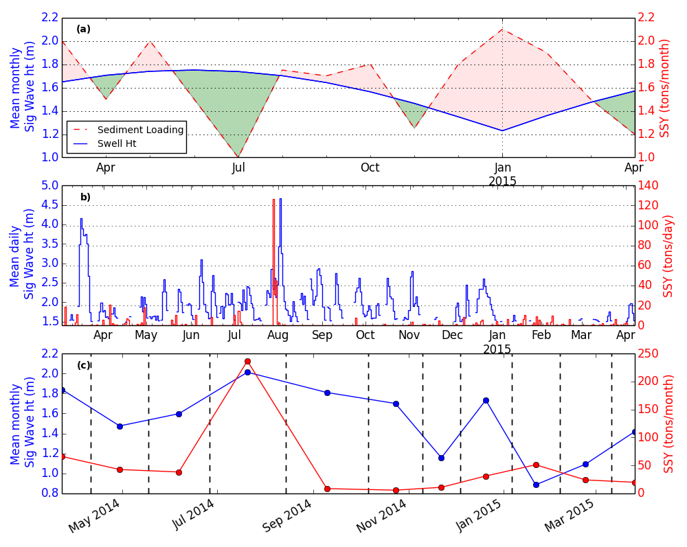

Figure 4. Conceptual model of net sediment accumulation driven by interacting sediment input and wave-forced sediment removal

Discussion

Hard to say about sediment resuspension and movement since we have limited forcing data and sediment movement is complex in an area of complex bathymetry and sediment shape and density, not just particle size (Kench and Brander 2006; Hopley 2011)

This is at monthly scale over a year, SSY could be more important at longer timescales

Compare our results with more protected bays/reefs like Gray

Acknowledgements

This work was carried out in collaboration between San Diego State University and the US Geological Survey's Pacific Coral Reef Project. Funding was provided by the NOAA Coral Reef Conservation Program and the US Geological Survey's Coastal and Marine Geology Program. We would like to thank Dr. Michael Favazza for providing logistical support in the field. We would also like to thank Liv Herdman (USGS) and three anonymous reviewers who contributed excellent suggestions and timely reviews of our work. Use of trademark names does not imply USGS endorsement of products.

References

Basher L, Hicks D, Clapp B, Hewitt T (2011) Sediment yield response to large storm events and forest harvesting, Motueka River, New Zealand. New Zeal. J. Mar. Freshw. Res. 45:333–356

Bégin C, Brooks G, Larson R a., Dragićević S, Ramos Scharrón CE, Coté IM (2014) Increased sediment loads over coral reefs in Saint Lucia in relation to land use change in contributing watersheds. Ocean Coast. Manag. 95:35–45

Bellwood DR, Fulton CJ (2008) Sediment-mediated suppression of herbivory on coral reefs: Decreasing resilience to rising sea-levels and climate change? Limnol. Oceanogr. 53:2695–2701

Bever AJ, McNinch JE, Harris CK (2011) Hydrodynamics and sediment-transport in the nearshore of Poverty Bay, New Zealand: Observations of nearshore sediment segregation and oceanic storms. Cont. Shelf Res. 31:507–526

Bothner MH, Reynolds RL, Casso MA, Storlazzi CD, Field ME (2006) Quantity, composition, and source of sediment collected in sediment traps along the fringing coral reef off Molokai, Hawaii. Mar. Pollut. Bull. 52:1034–47

Clausing R, Annunziata C, Baker G, Lee C, Bittick S, Fong P (2014) Effects of sediment depth on algal turf height are mediated by interactions with fish herbivory on a fringing reef. Mar. Ecol. Prog. Ser. 517:121–129

Cochran SA, Gibbs AE, D’Antonio NL, Storlazzi CD (2016) Benthic habitat map of U.S. Coral Reef Task Force Faga‘alu Bay priority study area, Tutuila, American Samoa: U.S. Geological Survey Open-File Rport 2016-XXXX, XX.

Craig P (2009) Natural History Guide to American Samoa. National Park of American Samoa, Pago Pago, American Samoa

Downs C a, Ostrander GK, Rougee L, Rongo T, Knutson S, Williams DE, Mendiola W, Holbrook J, Richmond RH (2012) The use of cellular diagnostics for identifying sub-lethal stress in reef corals. Ecotoxicology 21:768–82

Draut AE, Bothner MH, Field ME, Reynolds RL, Cochran, S.A.Logan JB, Storlazzi CD, Berg CJ (2009) Supply and dispersal of flood sediment from a steep, tropical watershed: Hanalei Bay, Kaua’i, Hawai'i, USA. Geol. Soc. Am. Bull. 121:574–585

Duvert C, Nord G, Gratiot N, Navratil O, Nadal-Romero E, Mathys N, Némery J, Regüés D, García-Ruiz JM, Gallart F, Esteves M (2012) Towards prediction of suspended sediment yield from peak discharge in small erodible mountainous catchments (0.45–22km2) of France, Mexico and Spain. J. Hydrol. 454-455:42–55

Erftemeijer PL a, Riegl B, Hoeksema BW, Todd P a. (2012) Environmental impacts of dredging and other sediment disturbances on corals: A review. Mar. Pollut. Bull. 64:1737–1765

Fabricius KE (2005) Effects of terrestrial runoff on the ecology of corals and coral reefs: review and synthesis. Mar. Pollut. Bull. 50:125–46

Fabricius KE, De’ath G, Humphrey C, Zagorskis I, Schaffelke B (2012) Intra-annual variation in turbidity in response to terrestrial runoff on near-shore coral reefs of the Great Barrier Reef. Estuar. Coast. Shelf Sci. 1–9

Fallon SJ, White J c., McCulloch MT (2002) Porites corals as recorders of mining and environmental impacts : Misima Island , Papua New Guinea. 66:45–62

Feagaimaalii-Luamanu J (2016) High surf generated by TC Victor washes over roads and property. Samoa News

Field ME, Chezar H, Storlazzi CD (2012) SedPods: a low-cost coral proxy for measuring net sedimentation. Coral Reefs

Goatley CHR, Bellwood DR (2012) Sediment suppresses herbivory across a coral reef depth gradient. Biol. Lett. 8:1016–8

Heiri O, Lotter AF, Lemcke G (2001) Loss on ignition as a method for estimating organic and carbonate content in sediments : reproducibility and comparability of results. J. Paleolimnol. 25:101–110

Hettler J, Irion G, Lehmann B (1997) Environmental impact of mining waste disposal on a tropical lowland river system: a case study on the Ok Tedi Mine, Papua New Guinea. Miner. Depos. 32:280–291

Hoitink AJF, Hoekstra P (2003) Hydrodynamic control of the supply of reworked terrigenous sediment to coral reefs in the Bay of Banten (NW Java, Indonesia). Estuar. Coast. Shelf Sci. 58:743–755

Holst-Rice S, Messina A, Biggs TW, Vargas-Angel B, Whitall D (2016) Baseline Assessment of Fagaʻalu Watershed: A Ridge to Reef Assessment in Support of Sediment Reduction Activities and Future Evaluation of their Success.

Hopley D (2011) S. Encyclopedia of Modern Coral Reefs.

Kench PS, Brander RW (2006) Wave Processes on Coral Reef Flats: Implications for Reef Geomorphology Using Australian Case Studies. J. Coast. Res. 221:209–223

Klein CJ, Jupiter SD, Selig ER, Watts ME, Halpern BS, Kamal M, Roelfsema C, Possingham HP (2012) Forest conservation delivers highly variable coral reef conservation outcomes. Ecol. Appl. 22:1246–56

Messina AT, Biggs TW Contributions of human activities to suspended sediment yield during storm events from a steep, small, tropical watershed: Faga’alu, American Samoa. J. Hydrol.

Messina AT, Storlazzi CD, Biggs TW, Washburn L Eulerian and Lagrangian measurements of flow and residence time on a fringing reef flat embayment, American Samoa. Coral Reefs

Militello A, Scheffner NW, Thompson EF (2003) Hurrican-Induced Stage-Frequency Relationships for the Territory of American Samoa. USACOE Technical Report CHL-98-33.

Muzuka ANN, Dubi AM, Muhando CA, Shaghude YW (2010) Impact of hydrographic parameters and seasonal variation in sediment fluxes on coral status at Chumbe and Bawe reefs, Zanzibar, Tanzania. Estuar. Coast. Shelf Sci. 89:137–144

PACIOOS PIOOS (2016) WaveWatch III Samoa Regional Model. http://oos.soest.hawaii.edu/pacioos/

Perry C, Smithers SG, Gulliver P, Browne NK (2012) Evidence of very rapid reef accretion and reef growth under high turbidity and terrigenous sedimentation. Geology 40:719–722

Ramos-Scharrón CE, Macdonald LH (2007) Measurement and prediction of natural and anthropogenic sediment sources, St. John, US Virgin Islands. Catena 71:250–266

Rangel-Buitrago N, Anfuso G, Phillips M, Thomas T, Alvarez O, Forero M (2014) Characterization of wave climate and extreme events into the SW Spanish and Wales coasts as a first step to define their wave energy potential. J. Coast. Res. 70:314–319

Rotmann S, Thomas S (2012) Coral tissue thickness as a bioindicator of mine-related turbidity stress on coral reefs at Lihir Island, Papua New Guinea. Oceanography 25:52–63

Ryan KE, Walsh JP, Corbett DR, Winter a (2008) A record of recent change in terrestrial sedimentation in a coral-reef environment, La Parguera, Puerto Rico: a response to coastal development? Mar. Pollut. Bull. 56:1177–83

Santisteban JI, Mediavilla R, Lopez-Pamo E, Dabrio CJ, Zapata MBR, Garcia MJG, Castano S, Martínez-Alfaro PE (2004) Loss on ignition: a qualitative or quantitative method for organic matter and carbonate mineral content in sediments? J. Paleolimnol. 32:287–299

Seymour RJ (2011) Evidence for Changes to the Northeast Pacific Wave Climate. J. Coast. Res. 27:194–201

Storlazzi CD, Field ME, Bothner MH (2011) The use (and misuse) of sediment traps in coral reef environments: theory, observations, and suggested protocols. Coral Reefs 30:23–38

Storlazzi CD, Field ME, Bothner MH, Presto MK, Draut AE (2009) Sedimentation processes in a coral reef embayment: Hanalei Bay, Kauai. Mar. Geol. 264:140–151

Storlazzi CD, Norris BK, Rosenberger KJ (2015) The influence of grain size, grain color, and suspended-sediment concentration on light attenuation: Why fine-grained terrestrial sediment is bad for coral reef ecosystems. Coral Reefs 34:967–975

Thomas S, Ridd P V (2004) Review of methods to measure short time scale sediment accumulation. Mar. Geol. 207:95–114

Thompson EF, Demirbilek Z (2002) Wave Response, Pago Pago Harbor, Island of Tutuila, Territory of American Samoa. USACOE Coastal and Hydraulics Laboratory ERDC/CHL TR-02-20.

Vetter O (2013) Inter-Disciplinary Study of Flow Dynamics and Sedimentation Effects on Coral Colonies in Faga’alu Bay, American Samoa: Oceanographic Investigation Summary. NOAA CRCP Project #417.

Victor S, Neth L, Golbuu Y, Wolanski E, Richmond RH (2006) Sedimentation in mangroves and coral reefs in a wet tropical island, Pohnpei, Micronesia. Estuar. Coast. Shelf Sci. 66:409–416

Warrick JA, Mertes LAK, Washburn L, Siegel DA (2004) Dispersal forcing of southern California river plumes, based on field and remote sensing observations. Geo-Marine Lett. 24:46–52

Weber M, de Beer D, Lott C, Polerecky L, Kohls K, Abed RMM, Ferdelman TG, Fabricius KE (2012) Mechanisms of damage to corals exposed to sedimentation. Proc. Natl. Acad. Sci. 109:E1558–E1567

White J (1990) The use of sediment traps in high-energy environments. Mar. Geophys. Res. 12:145–152

Wolanski E, Richmond RH, Davis G, Bonito V (2003) Water and fine sediment dynamics in transient river plumes in a small, reef-fringed bay, Guam. Estuar. Coast. Shelf Sci. 56:1029–1040

Tables

Figure Captions

Figure xxx. Hypothetical phasing of monthly sediment loading from the watershed and offshore wave height *(Draut et al. 2009)*. Red shaded areas indicate a time of net terrigenous sediment accumulation and green shaded areas indicate a time of net terrigenous sediment removal and resuspension of marine-derived sediment.